Question 21:
Create a dictionary of five teachers and their subjects. Change the subject of one teacher.
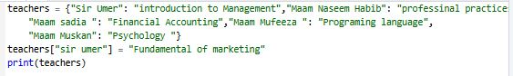
Output:
